Progress of NMCAA Early Head Start and Head Start Programs and Children in Achieving School Readiness Goals

EHS Home Based School Readiness Data Analysis 2021-22
 | % of indicators below expectations |  |  | % of indicators at/above expectations
Date | Fall | Winter | Spring | Fall | Winter | Spring
Social-Emotional | 14% | 12% | 11% | 86% | 88% | 89%
Perceptual, Motor, Physical | 9% | 7% | 5% | 91% | 93% | 95%
Approaches to Learning | 8% | 8% | 6% | 92% | 92% | 94%
Cognitive | 8% | 7% | 6% | 92% | 93% | 94%
Communication, Language | 24% | 22% | 19% | 76% | 78% | 81%
Literacy | 20% | 16% | 14% | 80% | 84% | 86%

NMCAA EHS Center-based and Child Care Partnership - School Readiness Data Analysis School Year 2021-2022 (Percentages reflect meeting or exceeding expectations)
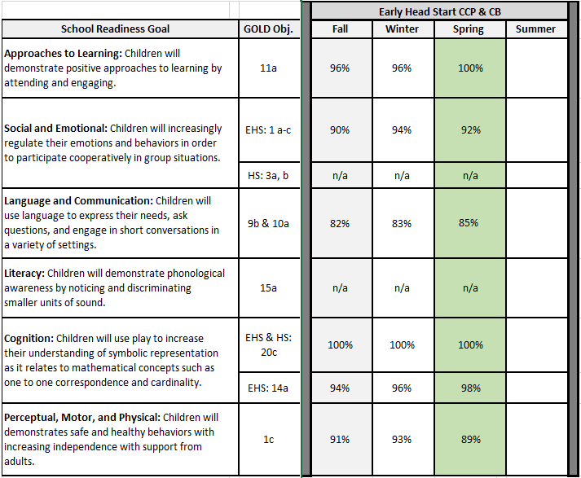

Head Start School Readiness Data Analysis 2021-22

School Readiness Goal | GOLD objective | Fall | Winter | Spring
Social and Emotional  - Children will increasingly balance the needs and rights of self and others | 3a | 73% | 83% | 87%
Social and Emotional  - Children will solve social problems when interacting with their peers | 3b | 50% | 67% | 79%
Language and Communication  - Children will speak clearly when engaging in conversations with peers and adults | 9b | 76% | 85% | 89%
Language and Communication  - Children will engage in conversations with their peer and adults | 10a | 68% | 80% | 86%
Approaches to Learning  - Children will demonstrate positive approaches to learning by attending and engaging. | 11a | 76% | 84% | 89%
Literacy  - Children will notice and discriminate rhymes | 15A | 34% | 54% | 67%
Cognitive  - Children will use play to increase their understanding of symbolic representation as it relates to correspondence and cardinality | 20c | 41% | 54% | 71%
Perceptual, Motor and Physical  - Children will demonstrate safe and healthy behaviors with increasing independence with support from adults | 1c | 73% | 87% | 90%

Domain | Fall | Winter | Spring
Social-emotional | 52% | 74% | 83%
Physical | 71% | 87% | 93%
Language | 63% | 76% | 84%
Cognitive | 56% | 77% | 85%
Literacy | 47% | 69% | 83%
Mathematics | 43% | 63% | 81%

